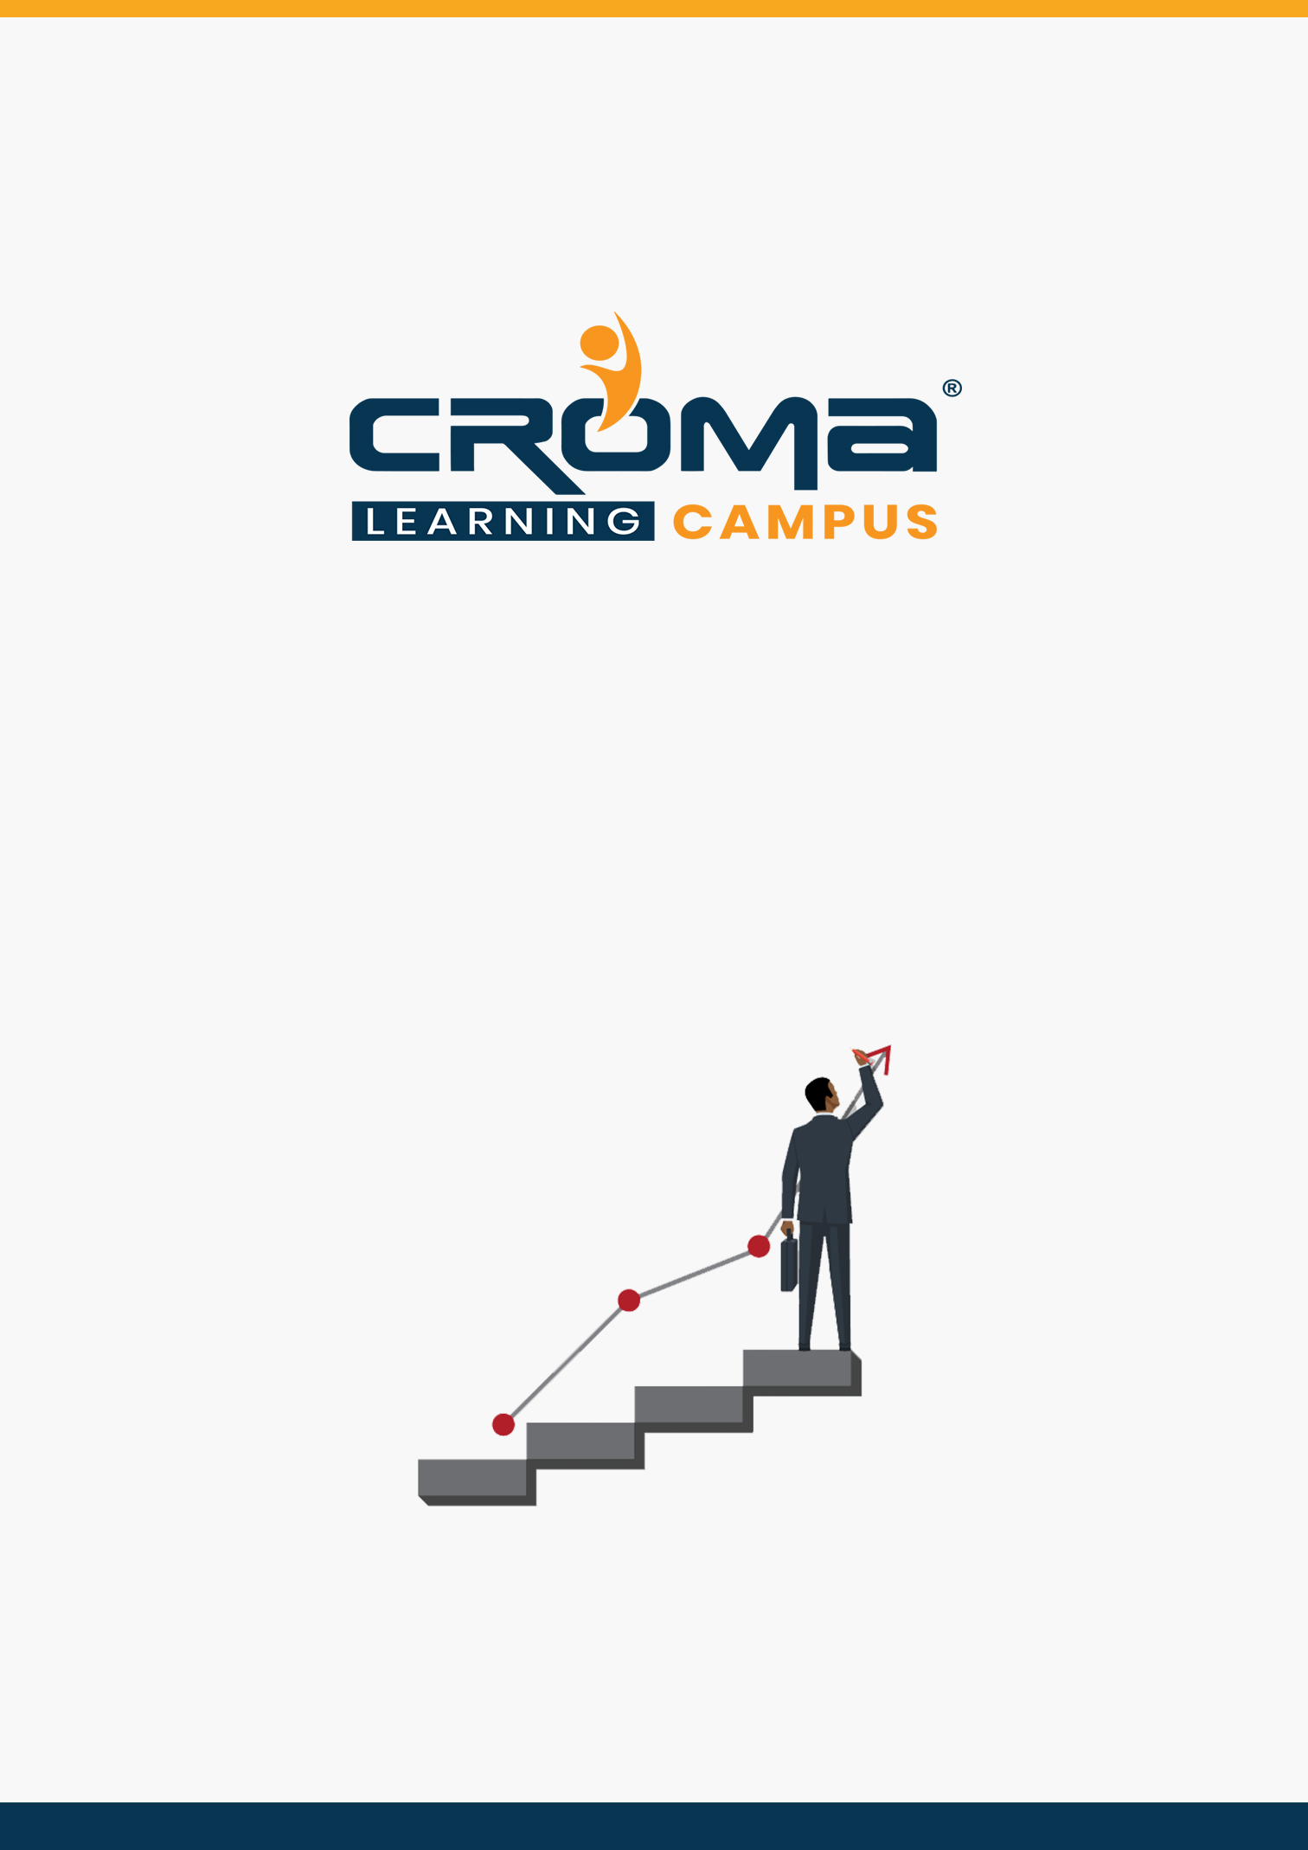

**Microsoft Dynamics 365**

**Supply Chain Management & Manufacturing**

**Training Curriculum**

**STRUCTURE**

**www.cromacampus.com | helpdesk@cromacampus.com | +91-120-4155255**

**Microsoft Dynamics 365 Supply Chain Management & Manufacturing Training Curriculum**

*“Become a Certified Microsoft Dynamics 365 expert by joining our comprehensive Training Program at Croma Campus by best industry experts”*

**About Croma Campus:**

Croma Campus Training & Development Private Limited is an education platform since 2010 providing rigorous industry-relevant programs designed and delivered in collaboration with world-class faculty and industry.

* Hands-On Live Projects
* Simulation Test Papers
* Industry Cases Studies
* 61,640+ Satisfied Learners
* 140+ Training Courses
* 100% Certification Passing Rate
* Live Instructor Classroom / Online Training
* 100% Placement Assistance

**Course Objectives:**

* Prepare yourself for the certification exam and clear your certification exam in the first attempt mostly.
* Add an attractive credential in your resume that is really appreciated by Companies.
* Improve your overall Microsoft dynamics skills and explore more job prospects with better salary packages.
* Boost your social media profiles especially LinkedIn by adding this certification and become one of the top persons to be chosen by industries.

**Course Description:**

Candidates for this exam are functional consultants who analyze business requirements and translates those requirements into fully realized business processes and solutions that implement industry best practices. Candidates serve as a key resource in implementing and configuring applications to meet business requirements.

Candidates for this exam have a fundamental understanding of accounting principles and financial operations of businesses, customer service, field service, manufacturing, retail, and supply chain management concepts.

Candidates for this exam typically specialize in one or more feature sets of Finance and Operations, including finance, manufacturing, and supply chain management. Candidates must have some knowledge of manufacturing practices.

**Certification Exam Structure:**

* Configure Dynamics 365 Supply Chain Management, Manufacturing (35-40%)
* Manage manufacturing processes (20-25%)
* Implement master planning for production (10-15%)
* Implement other manufacturing features (15-20%)

**Croma Campus Training Program Deliverables:**

* **Session Recordings** - Original Class Room Voice & Video Recording
* **Training Material** - Soft Copy Handbooks
* **Assignments** | Multiple Hands-on Exercises
* **Test Papers** - We provide **Practice Test** as part of our course to help you prepare for the actual certification exam.
* **Live Case Studies**
* **Live Projects** - Hands-on exercises and Project work. You will work on real time industry-oriented projects and assignments for each module to practice.
* **Key focus on Hands-on exercises and Project work**. You will work on real time industry-oriented projects.
* Faculty with more than **10+ Years of Experience** in the Industry.
* **Technical Resume Designing & Job Assistance:** With more than 100+ Clients across the Globe and we help learners to get a good job in their respective field. We also help learners with resume preparation.
* **Interview Q&A**
* **About Croma Campus Training Certificate:** Croma Campus will provide you with an industry-recognized (Certified by **ISO 9001:2015** & **E-Cell IIT Jodhpur**) course completion certificate which has lifelong validity.
* **How I Unlock my Croma Campus Certificate:** Attend Complete Batch & Submit at least One Completed Project.

**Course Content:**

**Module 1: Configure Dynamics 365 Supply Chain Management, Manufacturing (35-40%)**

**Configure and Manage the Production Control Module**

* manage product compliance
* configure commodity pricing
* configure scrap and waste
* differentiate and configure production parameters and statuses
* configure substitute items
* implement subcontracting
* configure production groups, production units, and production pools

**Configure and Manage Resources for Production Processes**

* implement and manage work calendars and working time
* configure inventory, product, storage, and tracking dimensions in production
* create and configure resource capabilities
* implement and manage resources and resource groups
* create and manage operations and routes

**Configure Process Manufacturing**

* configure batch reservations and expiration dates
* identify and configure batch attributes
* configure batch balancing
* configure co-products and by-products for batch orders
* configure planning items
* configure formulas by using scalable and percentage-based calculations
* configure formulas by using active ingredient-based calculations
* configure catch weight items

**Configure Discrete Manufacturing**

* create bill of materials (BOM) and item configurations
* create and release a dimension-based product master
* define configuration groups and routes for dimension-based product

**Configure Lean Manufacturing**

* create value streams and production flows
* configure production flow costing
* create Kanban rules

**Module 2: Manage manufacturing processes (20-25%)**

**Manage Batch Orders**

* create and process batch orders
* implement lot and batch control processes
* configure consolidated batch order processes
* create and process report as finished co-product journals
* manage batch order sequencing
* create and process a rework batch order

**Manage Production Orders**

* creating and process production orders
* create and process picking journals
* create and process job card journals
* create and process report as finished journals
* reset the status of a production order

**Manage Kanban Orders**

* process Kanban orders by using Kanban boards
* create and manage fixed, scheduled, and event Kanban
* implement activity-based subcontracting

**Module 3: Implement master planning for production (10-15%)**

**Configure and manage master planning**

* set up coverage groups and item coverage
* differentiate between action messages, delay messages, time fences, and negative days
* process and view planned orders

**Plan, schedule, and perform production capacity planning**

* define scheduling parameters
* view, monitor, and update production schedules
* configure capacity for production resources including machines, labour, and tooling

**Module 4: Implement other manufacturing features (15-20%)**

**Configure manufacturing execution**

* configure time and attendance prerequisites and parameters
* identify the capabilities of Manufacturing Execution
* process production and batch orders by using manufacturing execution processes
* configure job card devices and terminals
* register a worker for a job card device or terminal

**Configure costing policies**

* configure and manage costing sheets
* configure and use cost groups
* configure indirect costs
* configure and manage costing versions and cost categories
* configure and perform BOM/formula calculations

**Design product configuration models by using Product Configurator**

* create and build a product configuration model that includes components and
* subcomponents
* create and manage product configuration model components
* create calculations for product configuration models
* differentiate between table and expression constraints
* describe use cases for BOM lines and route operations
* configure and manage pricing for production configuration models
* describe the purpose and capabilities of the product configuration models

**Module 5: Placement Guide**

* Tips to clear an Interview
* Common Interview questions and answers
* Microsoft Dynamics 365 supply chain management and manufacturing Interview Questions and Answers
* Resume Building Guide
* Attempt for the related Global Certification Exam
* Earn Credentials and Start applying for Jobs